import pandas as pd
import numpy as np
import matplotlib.pyplot as plt
from sklearn.model_selection import train_test_split
from sklearn.preprocessing import StandardScaler
from sklearn.decomposition import PCA
from sklearn.svm import SVC
from sklearn.metrics import accuracy_score, classification_report, confusion_matrix

# 1. Load Dataset
df = pd.read_csv("/home/avcoe/wdbc.csv")

print("First 5 rows:")
print(df.head())

print("\nDataset Shape:")
print(df.shape)

print("\nColumn Names:")
print(df.columns)

# 2. Separate Features and Target
X = df.drop("diagnosis", axis=1)
y = df["diagnosis"]

print("\nNumber of features before PCA:", X.shape[1])

print("\nOriginal Feature Names:")
for i, feature in enumerate(X.columns, start=1):
print(f"{i}. {feature}")

print("\nClass Distribution:")
print(y.value_counts())

print("\nM = Malignant")
print("B = Benign")

# 3. Split Dataset into Training and Testing Sets
X_train, X_test, y_train, y_test = train_test_split(X,y,test_size=0.20,random_state=42,stratify=y)

print("\nTraining Samples:", X_train.shape[0])
print("Testing Samples :", X_test.shape[0])

# 4. Stadardize Features
scaler = StandardScaler()

X_train_scaled = scaler.fit_transform(X_train)
X_test_scaled = scaler.transform(X_test)

# 5. Classification BEFORE PCA using SVM
model_before = SVC(kernel="rbf",C=1.0,gamma="scale")

model_before.fit(X_train_scaled, y_train)

y_pred_before = model_before.predict(X_test_scaled)

accuracy_before = accuracy_score(y_test, y_pred_before)

print("\nClassification BEFORE PCA")
print("Classifier : SVM")
print("Kernel : RBF")
print("Number of Features :", X_train_scaled.shape[1])
print("Accuracy :", round(accuracy_before, 4))

print("\nClassification Report:")
print(classification_report(y_test, y_pred_before))

print("\nConfusion Matrix:")
print(confusion_matrix(y_test, y_pred_before))

# 6. Apply PCA with 2 Components for Visualization

scaler_visualization = StandardScaler()

X_scaled_visualization = scaler_visualization.fit_transform(X)

pca_2d = PCA(n_components=2)

X_pca_2d = pca_2d.fit_transform(X_scaled_visualization)

print("\nPCA for 2D Visualization")

print("Original Number of Features:", X.shape[1])
print("Reduced Number of Features :", X_pca_2d.shape[1])

print("\nExplained Variance Ratio:")

print("PC1:",round(pca_2d.explained_variance_ratio_[0], 4))

print("PC2:",round(pca_2d.explained_variance_ratio_[1], 4))

print("Total Variance Explained by PC1 and PC2:",round(np.sum(pca_2d.explained_variance_ratio_), 4))

# 7. PCA Visualization
plt.figure(figsize=(8, 6))

label_names = {"M": "Malignant","B": "Benign"}

for label in y.unique():
plt.scatter(
X_pca_2d[y == label, 0],
X_pca_2d[y == label, 1],
label=label_names[label],
alpha=0.7
)

plt.xlabel("PC 1")
plt.ylabel("PC 2")
plt.title("PCA Visualization of WDBC")
plt.legend(title="Diagnosis")
plt.grid(True)
plt.tight_layout()
plt.show()

# 8. PCA for Classification
pca = PCA(n_components=0.95)

X_train_pca = pca.fit_transform(X_train_scaled)
X_test_pca = pca.transform(X_test_scaled)

number_of_pca_features = X_train_pca.shape[1]

print("\nPCA for Classification")

print("Number of Features Before PCA:",X_train_scaled.shape[1])

print("Number of Features After PCA :",number_of_pca_features)

print("Total Explained Variance:",round(np.sum(pca.explained_variance_ratio_),4))

# 9. Display PCA Feature Names

pca_feature_names = [
f"PC{i + 1}"
for i in range(number_of_pca_features)
]

print("\nFeatures After PCA:")

for i, feature in enumerate(pca_feature_names, start=1):
print(f"{i}. {feature}")

# 10. Display Variance Explained by Each PCA Component

print("\nVariance Explained by Each PCA Component:")

for i, variance in enumerate(
pca.explained_variance_ratio_,
start=1
):
print(f"PC{i}: {variance:.4f} "f"({variance * 100:.2f}%)")

# 11. Classification AFTER PCA using SVM
model_after = SVC(kernel="rbf",C=1.0,gamma="scale")

model_after.fit(X_train_pca, y_train)

y_pred_after = model_after.predict(X_test_pca)

accuracy_after = accuracy_score(y_test, y_pred_after)

print("\nClassification AFTER PCA")

print("Classifier : SVM")
print("Kernel : RBF")
print("Number of PCA Features :", number_of_pca_features)
print("Accuracy :", round(accuracy_after, 4))

print("\nClassification Report:")
print(classification_report(y_test, y_pred_after))

print("\nConfusion Matrix:")
print(confusion_matrix(y_test, y_pred_after))

# 12. Final Comparison
difference = accuracy_after - accuracy_before

print("\nFinal Comparison")

print("Original Features :", X.shape[1])
print("Features After PCA :", number_of_pca_features)

print("Accuracy Before PCA :",round(accuracy_before, 4))

print("Accuracy After PCA :",round(accuracy_after, 4))

print("Accuracy Difference :",round(difference, 4))

# 13. Accuracy Comparison Bar Chart

methods = ["Before PCA", "After PCA"]
accuracies = [accuracy_before, accuracy_after]

plt.figure(figsize=(6, 5))

bars = plt.bar(methods, accuracies)

plt.ylabel("Accuracy")
plt.title("SVM Classification Accuracy Before and After PCA")
plt.ylim(0.90, 1.0)

for bar, accuracy in zip(bars, accuracies):
plt.text(
bar.get_x() + bar.get_width() / 2,
accuracy + 0.002,
f"{accuracy:.4f}",
ha="center"
)

OUTPUT:

/usr/lib/python3/dist-packages/scipy/__init__.py:146: UserWarning: A NumPy version >=1.17.3 and <1.25.0 is required for this version of SciPy (detected version 1.26.4
warnings.warn(f"A NumPy version >={np_minversion} and <{np_maxversion}"
First 5 rows:
diagnosis mean radius ... worst symmetry worst fractal dimension
0 M 17.99 ... 0.4601 0.11890
1 M 20.57 ... 0.2750 0.08902
2 M 19.69 ... 0.3613 0.08758
3 M 11.42 ... 0.6638 0.17300
4 M 20.29 ... 0.2364 0.07678

[5 rows x 31 columns]

Dataset Shape:
(569, 31)

Column Names:
Index(['diagnosis', 'mean radius', 'mean texture', 'mean perimeter',
'mean area', 'mean smoothness', 'mean compactness', 'mean concavity',
'mean concave points', 'mean symmetry', 'mean fractal dimension',
'radius error', 'texture error', 'perimeter error', 'area error',
'smoothness error', 'compactness error', 'concavity error',
'concave points error', 'symmetry error', 'fractal dimension error',
'worst radius', 'worst texture', 'worst perimeter', 'worst area',
'worst smoothness', 'worst compactness', 'worst concavity',
'worst concave points', 'worst symmetry', 'worst fractal dimension'],
dtype='object')

Number of features before PCA: 30

Original Feature Names:
1. mean radius
2. mean texture
3. mean perimeter
4. mean area
5. mean smoothness
6. mean compactness
7. mean concavity
8. mean concave points
9. mean symmetry
10. mean fractal dimension
11. radius error
12. texture error
13. perimeter error
14. area error
15. smoothness error
16. compactness error
17. concavity error
18. concave points error
19. symmetry error
20. fractal dimension error
21. worst radius
22. worst texture
23. worst perimeter
24. worst area
25. worst smoothness
26. worst compactness
27. worst concavity
28. worst concave points
29. worst symmetry
30. worst fractal dimension

Class Distribution:
diagnosis
B 357
M 212
Name: count, dtype: int64

M = Malignant
B = Benign

Training Samples: 455
Testing Samples : 114

Classification BEFORE PCA
Classifier : SVM
Kernel : RBF
Number of Features : 30
Accuracy : 0.9737

Classification Report:
precision recall f1-score support

B 0.96 1.00 0.98 72
M 1.00 0.93 0.96 42

accuracy 0.97 114
macro avg 0.98 0.96 0.97 114
weighted avg 0.97 0.97 0.97 114

Confusion Matrix:
[[72 0]
[ 3 39]]

PCA for 2D Visualization
Original Number of Features: 30
Reduced Number of Features : 2

Explained Variance Ratio:
PC1: 0.4427
PC2: 0.1897
Total Variance Explained by PC1 and PC2: 0.6324

PCA for Classification
Number of Features Before PCA: 30
Number of Features After PCA : 10
Total Explained Variance: 0.9521

Features After PCA:
1. PC1
2. PC2
3. PC3
4. PC4
5. PC5
6. PC6
7. PC7
8. PC8
9. PC9
10. PC10

Variance Explained by Each PCA Component:
PC1: 0.4459 (44.59%)
PC2: 0.1855 (18.55%)
PC3: 0.0958 (9.58%)
PC4: 0.0659 (6.59%)
PC5: 0.0562 (5.62%)
PC6: 0.0399 (3.99%)
PC7: 0.0221 (2.21%)
PC8: 0.0161 (1.61%)
PC9: 0.0128 (1.28%)
PC10: 0.0117 (1.17%)

Classification AFTER PCA
Classifier : SVM
Kernel : RBF
Number of PCA Features : 10
Accuracy : 0.9649

Classification Report:
precision recall f1-score support

B 0.95 1.00 0.97 72
M 1.00 0.90 0.95 42

accuracy 0.96 114
macro avg 0.97 0.95 0.96 114
weighted avg 0.97 0.96 0.96 114

Confusion Matrix:
[[72 0]
[ 4 38]]

Final Comparison
Original Features : 30
Features After PCA : 10
Accuracy Before PCA : 0.9737
Accuracy After PCA : 0.9649
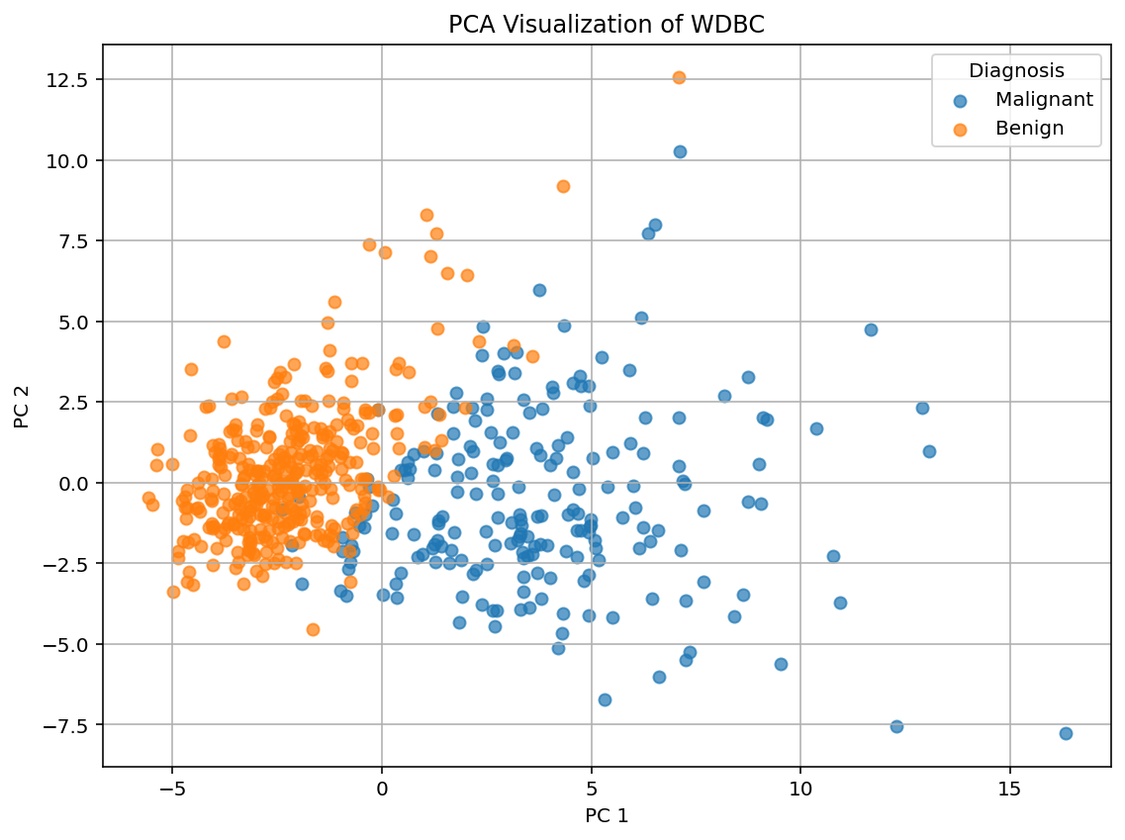
Accuracy Difference : -0.0088



